# PROJECT PLAN SCOPE

|  |  |
| --- | --- |
| **Chutoy Dating** | **DATE SUBMITTED** |
|  | 26/05/2020 |
| **PROJECT OBJECTIVES** | |
| The goal for this dating app is to enhance, expand and improve the traditional online dating experience for mobile users, with a strong emphasis on more user choices and options.   * We will have a completely functional app that stores the data in a secure location, that stands out from the others. * We will have an office that is fitted out well enough to equip technicians and developers to be able to support and maintain the app efficiently. * There will be sufficient procedures and business plans to keep the company safe and successful. * Our project will be completed under the budget of $1,000,000.00 by doing so the team will receive wages for the first year. * We will complete the project within the 10 weeks with multiple members helping in other areas when they can. | |

## Project Deliverables

|  |  |
| --- | --- |
| **DELIVERABLE NO.** | **DESCRIPTION** |
| 1 | Signing the lease for the office |
| 2 | Finalizing telecommunication contracts |
| 3 | Finalizing the AWS contract |
| 4 | Completing security policies |
| 5 | Development of the database, getting a test database available. |
| 6 | Testing commences on the test database |
| 7 | Signing off on the recommendations of the penetration test |
| 8 | User interface complete |
| 9 | Signing off on the security of the database |
| 10 | Website launched |
| 11 | Finalizing the code |
| 12 | Finalizing the internal procedures |
| 13 | Finalizing all security documentation |
| 14 | Finalizing the Disaster recovery plan |
| 15 | Completing user documentation |

## Work Breakdown Structure

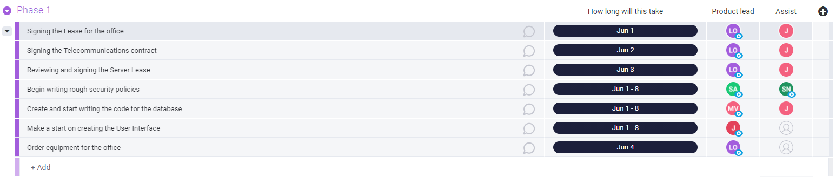

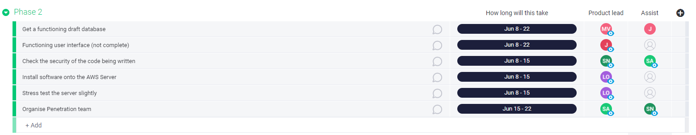

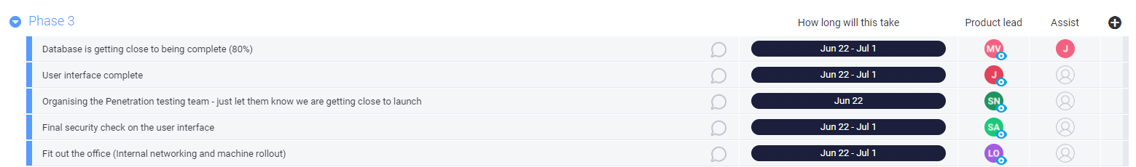

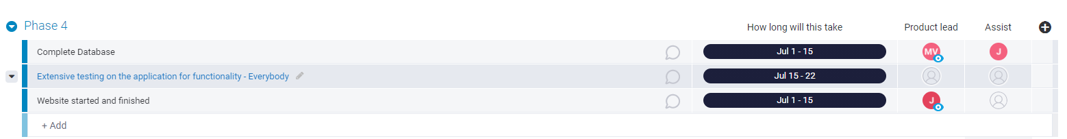

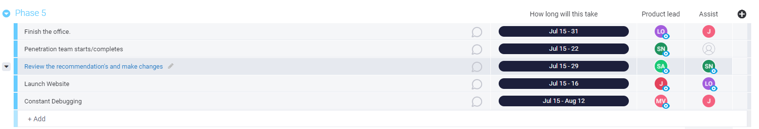

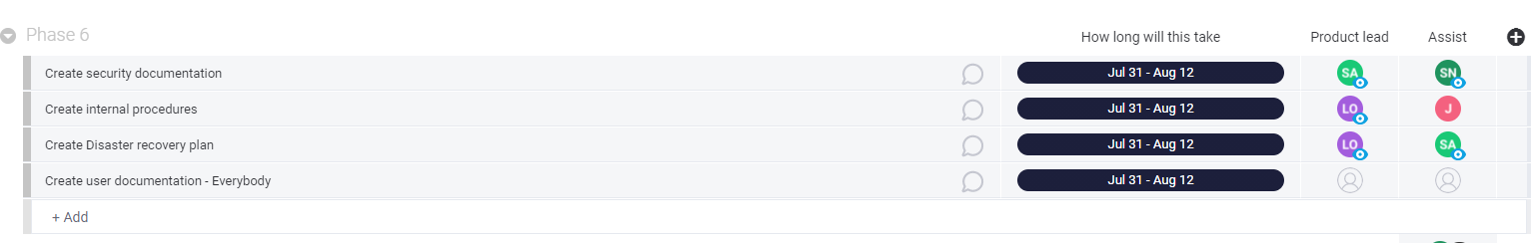

## Out of Scope

|  |  |
| --- | --- |
| This project **will NOT accomplish or include** the following: | * We will not look to staff the company once the launch has happened. * Training will not be provided during this project. * Updates after launch * Features not explained in the project proposal. * We have no marketing plans within this project. * Expansions. |

## Project Constraints

|  |  |
| --- | --- |
| **PROJECT START DATE** | 01/06/2021 |
| **LAUNCH / GO-LIVE DATE** | 13/08/2021 |
| **PROJECT END DATE** | 12/08/2021 |
| **LIST ANY HARD DEADLINE(S)** | Server must be operational so that the other teams can work on it. 15/06/2021  App must be functional well before launch to allow testing. 15/07/2021  Office must be ready to go nearing launch. 31/07/2021  Server must be secure. 29/07/2021  All documentation must be finished. 12/08/2021  App must go live. 13/08/2021 |
| **LIST OTHER DATES / DESCRIPTIONS OF KEY MILESTONES** | Database should be complete by 15th of July.  Finishing up the security touches on the application will mean we are basically ready to launch. 22nd of July  Documentation does not have to be done at launch but should not be elongated as this will be the final step before signing off. |
| **BUDGET CONSTRAINTS** | There should be no budget constraints, we will pay for the server up front for the year with cash. All parties are aware that depending on what is left over will affect their salaries.  The money for the penetration team will be separate from the budget from this as agreed upon with investors. |
| **QUALITY OR PERFORMANCE CONSTRAINTS** | There could be an issue with the amount of time the developers have to launch the database, there is a strict deadline on this. |
| **EQUIPMENT / PERSONNEL CONSTRAINTS** | There may be a delay on getting all the office equipment needed, but we have given a few days for it to arrive.  There may be a problem with how much time the DEV team must produce their products.  System admin does have a small-time frame from when we are provided access to the AWS server and for how long it will take to install what is required. |
| **REGULATORY CONSTRAINTS** | There could be a constraint of copyright, there is a lot of other dating apps out there, we need to be clear on what separates us from the others and focus on this.  Enter any legal, policy, or other regulatory constraints. |

## Updated Estimates

|  |  |
| --- | --- |
| **Estimate the hours required to complete the project.** | If each member works roughly 50 hours a week, with 10 weeks our projected hours will be 3,500 |

## Approvals

The approval is only to be signed off when all parties believe the project has been completed.

|  |  |  |  |
| --- | --- | --- | --- |
| **STAKEHOLDER NAME** | **ROLE OF STAKEHOLDER** | **DATE SUBMITTED FOR APPROVAL** | **DATE APPROVAL RECEIVED** |
| Jack | Director | 12/08/2021 |  |
| Liam | Director | 12/08/2021 |  |
| Josh | Director | 12/08/2021 |  |
| Mia | Director | 12/08/2021 |  |
| Stephanie | Director | 12/08/2021 |  |
| Sean | Director | 12/08/2021 |  |
| Investor | Director | 12/08/2021 |  |